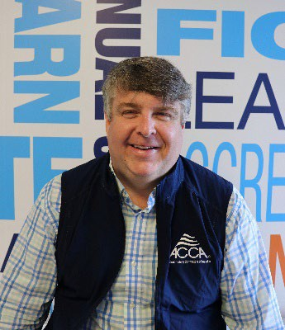
BARTON JAMES
Biographical Statement

Air Conditioning Contractors of America (ACCA)
President & CEO
barton.james@acca.org / Office: (703) 575-4477 / Mobile: (202)577-3990

Bart James serves as the president and chief executive officer of the Air Conditioning
Contractors of America, a (501©(6) non-profit organization and President of the Educational Institute, the ACCA’s workforce development and education (501©(3) organization. ACCA is the largest North America trade association dedicated to representing HVACR residential and commercial businesses. Bart is a leading advocate for over 3000 businesses that employee over 100,000 men and women who are responsible designing, installing, and maintaining HVACR systems that heat and cool our homes and offices, protect our food supply, ensure the possibility of modern medicine, and enable data centers to operate. In the United States alone this equal over $160 billion in annual sales.

Since Bart took the helm, the ACCA has dramatically expanded its issue advocacy and enhanced the organization’s influence and ability to mobilize at the state and local level to fight for contractor’s interest. Simultaneously, ACCA’s Political Action Committee (ACCA PAC) has grown to the largest in the HVACR Industry. With HVACR contractors facing an urgent need for talented and skilled workers, Bart is also a champion for connecting more Americans with rewarding careers in the modern HVACR industry and for closing the opportunity gap.

Under Bart’s leadership, the ACCA has become a trusted resource for services, and networking to support the business development interest of HVACR contractors, all while maintaining and expanding ACCA’s long history of setting and maintaining the standards and recognition for the importance of quality installation and service and maintenance. Bart is recognized as forceful and effective leader of the HVACR Industry. In 2021 he guided the advocacy work during the COVID-19 pandemic that secured the “essential” designation for the HVACR industry, as well as changing the depreciation schedule for commercial HVAC equipment from 39.5 year deprecation schedule to immediate in 2018 as part of the Tax Cuts and Jobs Act.

Driven by the values instilled in him by his roots growing up in Pine Bluff, Arkansas, and decades of experience working in state and national government and politics, Bart has built trusted relationships across multiple presidential administrations and with top leaders in both parties. He and the ACCA team have proven effective time and time again at navigating the complexities of policymaking in the nation’s capital to deliver real results for ACCA’s 3000 member companies.

Prior to his appointment as ACCA president and CEO in February 2019, Bart’s role at the organization included service as senior vice president of government relations and advocacy. His previous experience includes serving thirteen years as the Executive Director of the National Mitigation Banking Association, Director of Advocacy for the Land Trust Alliance, and Director of Public Policy for Ducks Unlimited. During this time, he designed and implemented strategic plans, built political advocacy campaigns and directed lobbying and communications activities.

Bart has also spent a decade working in staff leadership roles in the U.S. House of Representatives for Congressman Jay Dickey (R-AR), and Republican National Committee’s Opposition Research division, and serving as a political appointee in

President George W. Bush’s Administration at the United States Small Business Administration, the United States Department of Agriculture.

Bart is active in numerous charitable endeavors, including promoting and protecting future quality hunting, fishing, and outdoor recreation opportunities for youth.

Bart and his wife Danielle, split their time between Little Rock, Arkansas and Washington, D.C. with their twin boys Palmer and Preston and dog Lou and Cheddar the cat.

